Lab (Mail Server)-Configure Postfix, Dovecot Mail Server and

Thunderbird Email Client on Linux CentOS9

* **Network Diagram**

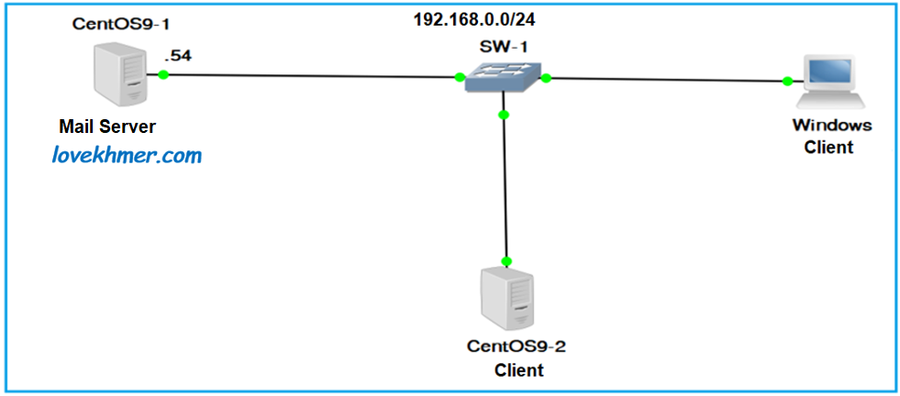

**INTRODUCTION**

* We chose **Postfix mail server (SMTP Server)**, which is very popular and common among system administrators today and it is the default mail server on most modern Linux distros.
* **Dovecot** is an open source **IMAP and POP3 mail server** for Unix/Linux systems.
* Working with mail in **command modes** little bit difficult for us. So we will install a **webmail client** called **Squirrelmail** to send/receive emails via a web browser.

**ជំហាន (Steps):**

**I. Installing and Configuring Postfix**

1. **Install (Online)**

yum -y install **postfix**

**2. Create DNS zone and add the Mail server MX records in the forward zone file.**

An MX record (Mail Exchange record) is used to specify the email server responsible for receiving the email messages on behalf of a domain. It points to the address of the mail server where emails should be delivered. MX records play a crucial role in ensuring that emails are routed correctly across the internet. The MX record is like an address book for emails. It tells email sending servers which server to use when delivering emails to a particular domain. It specifies the domain’s mail server and its priority. When someone sends an email, the MX record helps determine where to send it by listing the server’s name and a priority number.

The MX record contains two main pieces of information, the mail server’s hostname and its priority value. The **hostname** indicates the domain name of the email server, such as mail.lovekhmer.com, and **Priority** value is represented as a numerical preference that allows for the designation of multiple mail servers. Lower values indicate higher priority, meaning that mail servers with lower priority values are attempted first for email delivery.

* **Create Zones**

**vim** /etc/**named.conf**

**//do the following changes**:

listen-on port 53 { 192.168.0.54; };

allow-query { any; };

zone "lovekhmer.com" IN {

type master;

file "fwd.lovekhmer.com";

allow-update { none; };

};

zone "0.168.192.in-addr.arpa" IN {

type master;

file "rev.lovekhmer.com";

allow-update { none; };

};

**>> Save and exit from named.conf file**

**esc:wq**

* **Now you need to create zone files**

cd /var/named/

vim **fwd.lovekhmer.com**

**$TTL 1D**

**@ IN SOA linuxserver1. lovekhmer.com. root. lovekhmer.com. (**

**0 ; serial**

**1D ; refresh**

**1H ; retry**

**1W ; expire**

**3H ) ; minimum**

**IN NS linuxserver1.lovekhmer.com.**

**IN MX 10 mail.lovekhmer.com.**

**linuxserver1 IN A 192.168.0.54**

**mail IN A 192.168.0.54**

**>>Save and exit from fwd.lovekhmer.com file.**

**esc:wq**

* **Restart the service and test the result configuration of DNS Server**

systemctlrestart **named**

* **Use nslookup and dig commands to test**

**nslookup mail.lovekhmer.com**

Server: 192.168.0.54

Address: 192.168.0.54#53

Name: mail.lovekhmer.com

Address: 192.168.0.54

**3. Configure Linux Mail Server-Postfix**

* **You can find the main configuration for Postfix mail server in /etc/postfix/main.cf file**.
* **This file contains a lot of options like:**

>> myhostname (#line 94)

* This option is used for specifying the hostname of the mail server. This is the Internet hostname which Postfix will receive emails on it (Default: fully-qualified domain name).
* **It is written like this:**

myhostname = linuxserver1.lovekhmer.com

>> mydomain #line 102

* This option is the mail domain that you will be servicing, like lovekhmer.com
* **The syntax is like this:**

mydomain = lovekhmer.com

>> myorigin #line 118

* The **myorigin** configuration key specifies the origin domain for all mail sent through your server. While, by default, **myorigin** is configured to use your server hostname, you may want to change it to your actual domain name. You can accomplish this by setting the configuration key as follows:

myorigin = $mydomain

>> inet_interfaces = localhost #line 135 - change to all

* The **inet_interfaces** parameter specifies the network interface addresses that this mail system receives mail on. Specify "all" to receive mail on all network interfaces and "loopback-only" to receive mail on loopback network interfaces only. By default, the software claims all active interfaces on the machine. The parameter also controls delivery of mail to user@[ip.address].

inet_interfaces = all.

>> inet_protocols = all#Line 138 | keep default

* The Internet protocols Postfix will attempt to use when making or accepting connections. Specify one or more of "ipv4" or "ipv6", separated by whitespace or commas. The form "all" is equivalent to "ipv4, ipv6" or "ipv4", dependingon whether the operating system implements IPv6.

inet_protocols = all

>> mydestination#line 183

* **Mydestinatio**n (the list of domains that will be delivered to) lets Postfix know which domains your server will accept mail from. In other words, mail sent to any of the domains listed in **mydestination** will be delivered to local mail boxes. Add **$mydomain** at the end

mydestination = $myhostname, localhost.$mydomain, localhost, $mydomain

>> mynetworks = 192.168.0.0/24, 127.0.0.0/8#line 283

* A list of trusted IP addresses that may send or relay mail through the server. Users attempting to send email through the server using IP addresses not listed here will be rejected.

mynetworks = 192.168.0.0/24, 127.0.0.0/8

>> home_mailbox = Maildir/#line no 438 – uncomment

* The home_mailbox parameter specifies the optional pathname of a

mailbox file relative to a user's home directory.

home_mailbox = Maildir/

**>> Save and exit from main.cf file**

**esc:wq**

**>>To check syntax error**

**postfix check**

**>> Start & Enable Postfix service:**

**systemctl start postfix**

**systemctl enable postfix**

**>> Postfix with Firewall**

**firewall-cmd --permanent --add-service=smtp**

**firewall-cmd --reload**

**4. Testing Postfix**

To test our Postfix setup, we will need a user. So firstly we will add a new user in our machine & assign it a password.

**>> Create a test user called sok.**

useradd sok

passwd sok

Mail Account: sok@lovekhmer.com

**>> Install Telnet Client**

yum install telnet -y

**>> Next we will telnet into our smtp Server to access our Postfix mail server:**

**telnet mail.lovekhmer.com smtp**

& you will see a screen with following:

[root@linuxserver1 ~]# telnet mail.lovekhmer.com smtp

Trying 192.168.0.54...

Connected to mail.lovekhmer.com.

Escape character is '^]'.

220 linuxserver1.lovekhmer.com ESMTP Postfix

Now to connect to you mail server, type: **ehlo mail.lovekhmer.com**

**ehlo mail.lovekhmer.com**

**250-linuxserver1.lovekhmer.com**

250-PIPELINING

250-SIZE 10240000

250-VRFY

250-ETRN

250-STARTTLS

250-ENHANCEDSTATUSCODES

250-8BITMIME

250-DSN

250-SMTPUTF8

1. UNKING

**To send a mail, type your user name with the following command**

**mail from:sok** ## Type this - mail sender address##

1. **1.0 Ok**

**Then enter recipient mail address**

**rcpt to:sok** ## Type this - mail receiver address **##**

1. **1.5 Ok**

**& enter the word “data” and then the mail you want to type**

**data** ## Type this to input email message ##

**354 End data with <CR><LF>.<CR><LF>**

**This is a mail test ! ## Enter the boddy of the email ##.**

**## Type dot (.) to complete message ##**

**To exit from the session, type: quit**

**quit**## type this to quit from mail ##

221 2.0.0 Bye

Connection closed by foreign host.

**Now, let’s check if the user has received any mail or not, go to user’s default mail directory for new mails which is**

**/home/sok/Maildir/new**. Next list the directory items in the folder.

And you should see an item something like **‘1719372670.Vfd0.linuxserver1.lovekhmer.com’,** that’s the mail that was sent by user ‘sok’. To read it, you can use ‘cat’ command.

**So, our Postfix is working fine & we will move to configuring Dovecot.**

**II. Installing and Configuring Dovecot**

1. **Install**

yum -y install **dovecot**

1. **Configuring Dovecot**

Open the dovecot configuration file /etc/dovecot/dovecot.conf. Find and uncomment the line as shown below.

**>> Uncomment the following line: ## Line 24 - umcomment ##**

protocols = imap pop3 lmtp submission

The LMTP (**Local Mail Transport Protocol**) server, used for delivery messages to

the users mailboxes

**Submission (Submission Protocol):**

A protocol used by mail clients to send emails to a mail server, often used in conjunction with SMTP for email transmission.

**>> Uncomment and change # line 30: ( if not use IPv6 )**

listen = * , ::

**>> Save and exit from dovecot.conf file.**

esc:wq

**>> Mail location**: To set the location for your mail use the configuration file at /etc/dovecot/conf.d/10-mail.conf

vim /etc/dovecot/conf.d/10-mail.conf

**>> Uncomment # Line 24**

mail_location = maildir:~/Maildir

**>> Save and exit from** 10-mail.conf **file**

esc:wq

**>> Authentication process file:**

**Open the file /etc/dovecot/conf.d/10-auth.conf**

**>> Uncomment ## line 10**

disable_plaintext_auth = yes(Default setting)

You need to change from “yes” to “no” to use plain text authentication because

Virtual servers don’t have SSL/TLS certificate:

disable_plaintext_auth = no

**>> Add a letter "login“ to it ## Line 100 - ##**

auth_mechanisms = plain login

**>> Save and exit from 10-auth.conf file**

esc:wq

**>> Open the file**/**etc/dovecot/conf.d/10-ssl.conf**

**>> changes ssl = require to ssl = no ## line 8**

ssl = no

**>> Save and exit from 10-ssl.conf file**

esc:wq

**>> & last file to edit is /etc/dovecot/conf.d/10-master.conf, A listener is added to Dovecot. Postfix will use this listener to communicate with Dovecot: (uncomment then add ‘postfix’ to it),**

**>> Uncomment # Line 101, 102,103 -and add "postfix“ into line 102 & 103**

**mode = 0666**

**user = postfix**

**group = postfix**

**>> Save and exit from 10-master.conf file**

**esc:wq**

**>> Start Dovecot service:**

**systemctl start dovecot**

**systemctl enable dovecot**

**>> Dovecot with Firewall**

**firewall-cmd --permanent --add-service={pop3,imap}**

**firewall-cmd --reload**

**>> Testing Dovecot**

**We will now test dovecot by again logging into our telnet session with POP3**

**telnet mail.lovekhmer.com pop3**

[root@linuxserver1 ~]# telnet mail.lovekhmer.com pop3

Trying 192.168.0.54...

Connected to mail.lovekhmer.com.

Escape character is '^]'.

+OK Dovecot ready.

Trying ::1…

* **Enter user & password,**

user sok ## log in as user sok ##

+OK

pass 123456## input user password ##

+OK Logged in.

* **To view mail, type:**retr 1

+OK 450 octets

Return-Path: <sok@lovekhmer.com>

X-Original-To: sok

Delivered-To: sok@lovekhmer.com

Received: from mail.lovekhmer.com (linuxserver1.lovekhmer.com [192.168.0.54])

by linuxserver1.lovekhmer.com (Postfix) with ESMTP id C1D3831CAD23

for <sok>; Sat, 29 Mar 2025 20:47:39 +0700 (+07)

Message-Id: <20250329134751.C1D3831CAD23@linuxserver1.lovekhmer.com>

Date: Sat, 29 Mar 2025 20:47:39 +0700 (+07)

From: sok@lovekhmer.com

This is a mail test!

.

* **To Quit, type*:* quit**

**As you see in the above, Dovecot is working!**

**III. Thunderbird (Email App)**

Working with mail in command modes little bit difficult for us. So we will install an email app called **Thunderbird.**

**>> Email Client:**

**Thunderbird is designed to manage emails, allowing you to send, receive, organize, and search your emails.**

**>> Open Source and Free:**

**It's developed and maintained by the Mozilla Foundation, a non-profit organization, and is available for free to anyone.**

**>> Cross-Platform:**

**It runs on Windows, macOS, and Linux operating systems.**

**>> Unified Inbox:**

**You can manage multiple email accounts in one place, with the option to view them in a unified inbox or separate folders.**

**>> Calendar and Contacts:**

**Thunderbird includes a built-in calendar and address book for managing your schedule and contacts.**

**>> Extensibility:**

**You can extend Thunderbird's functionality by installing add-ons and extensions.**

**Newsgroup and News Feed Client:**

**Thunderbird allows you to subscribe to and read newsgroups and news feeds.**

**>> Privacy Focused:**

**Thunderbird is designed to protect your privacy and does not track your data or display ads.**

**>> Local Email Application:**

**Thunderbird is a desktop application, meaning it installs and runs as a client on your device, rather than being a web-based application.**

1. **Install Thunderbird**

**[root@linuxserver1 ~]# yum install thunderbird –y**

**[root@linuxserver1 ~]#**

**[root@linuxserver1 ~]# rpm -qi thunderbird**

**Name : thunderbird**

**Version : 128.8.0**

**Release : 2.el9**

**Architecture: x86_64**

**Install Date: Fri 04 Apr 2025 07:43:52 PM +07**

**Group : Unspecified**

**Size : 333786833**

**License : MPLv1.1 or GPLv2+ or LGPLv2+**

**Signature : RSA/SHA256, Tue 11 Mar 2025 11:36:20 PM +07, Key ID 05b555b38483c65d**

**Source RPM : thunderbird-128.8.0-2.el9.src.rpm**

**Build Date : Tue 11 Mar 2025 09:51:56 PM +07**

**Build Host : x86-02.stream.rdu2.redhat.com**

**Packager : builder@centos.org**

**Vendor : CentOS**

**URL : http://www.mozilla.org/projects/thunderbird/**

**Summary : Mozilla Thunderbird mail/newsgroup client**

**Description :**

**Mozilla Thunderbird is a standalone mail and newsgroup client.**

**[root@linuxserver1 ~]#**

1. **Configure Your Mail Client (Mozilla Thunderbird)**

**>>** **Run Thunderbird and Click [Set up an account] - [Email].**

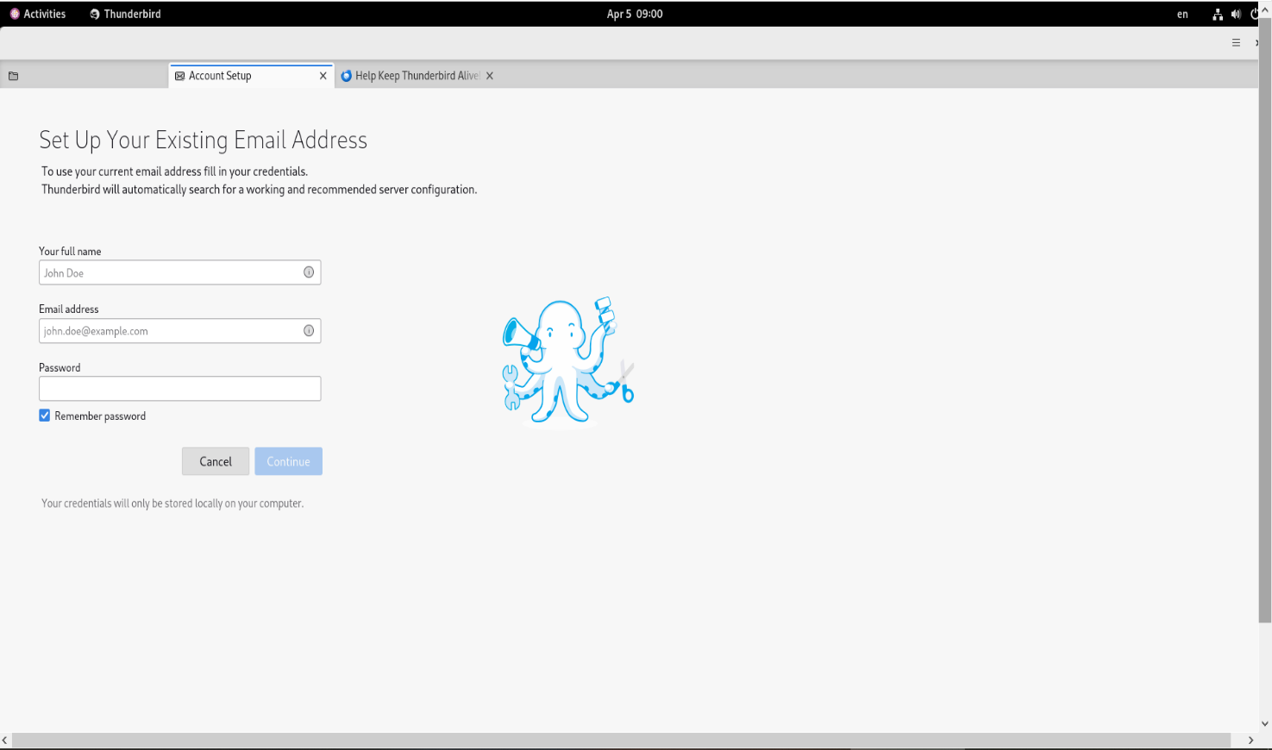

**>> Input any name which is displayed as email-Sender and also input**

**Email address and password, and then Click the [Continue] button**.

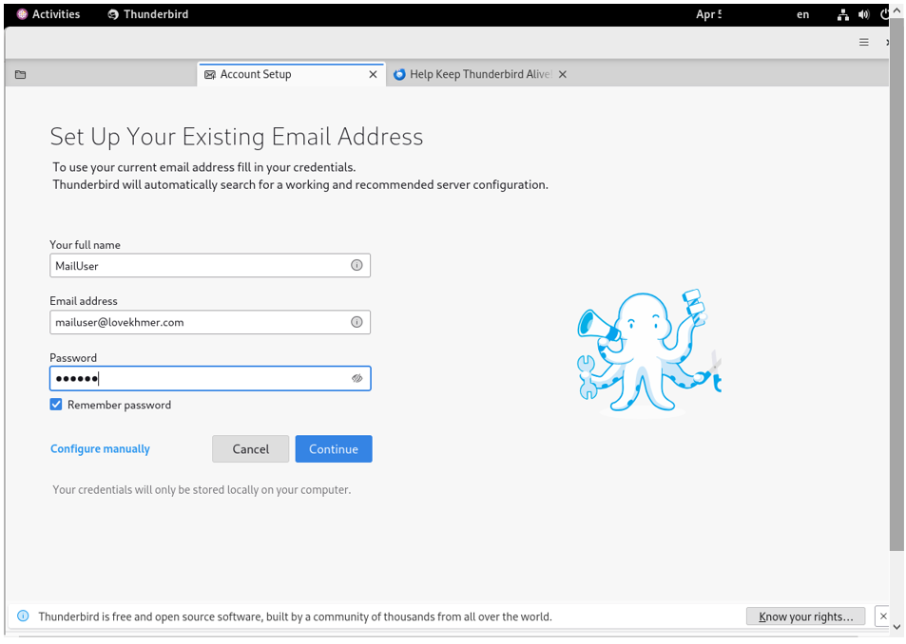

**>> Click the [Configure manually] link.**

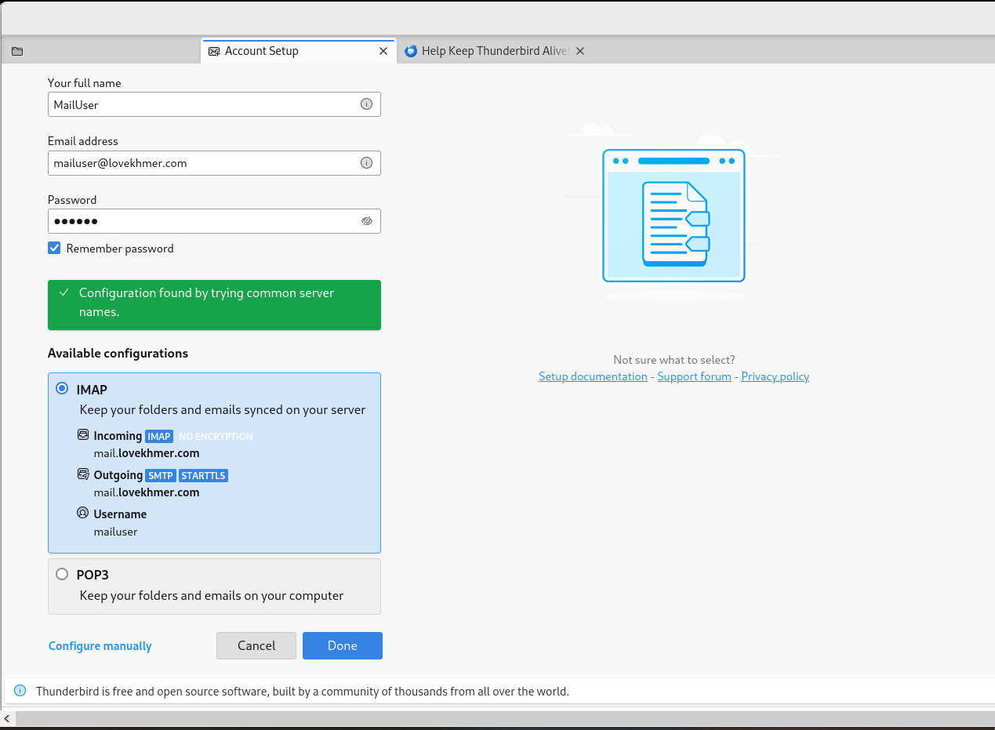

**>> Confirm selection and also confirm [Authentication] fields are selected [Normal password] like follows, then Click the [Done] to finish.**

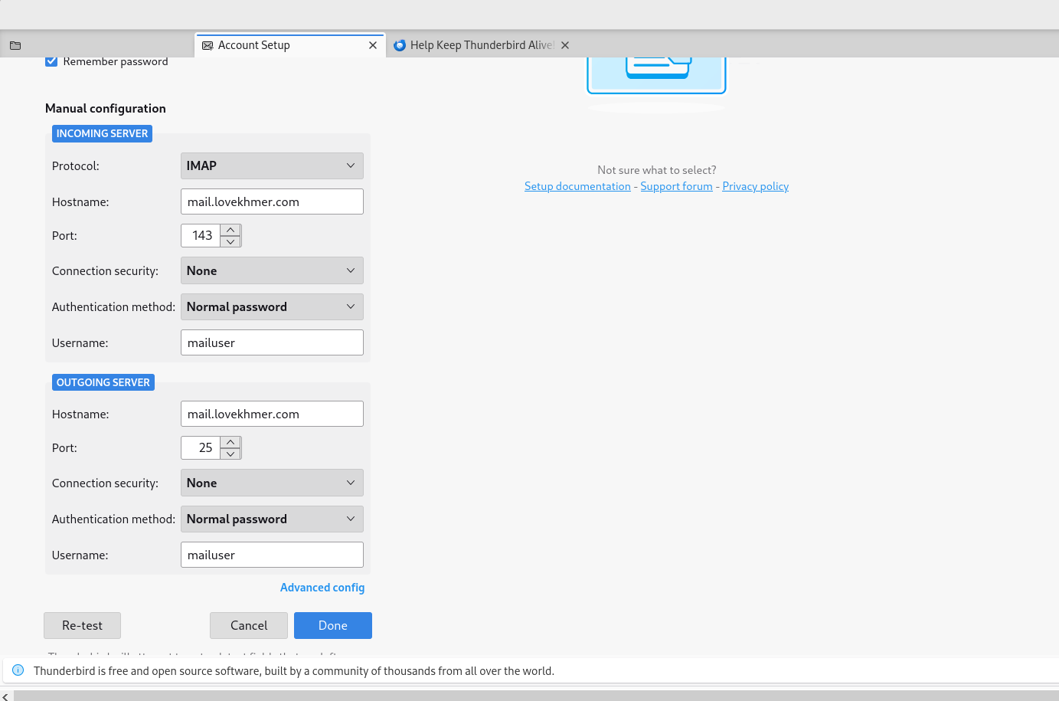

**>> The warnings is shown because connection is not encrypted. If OK, Click the [Confirm] button, If not OK, Configure more to**[**refer to SSL/TLS settings section**](https://www.server-world.info/en/note?os=CentOS_Stream_9&p=mail&f=5)**.**

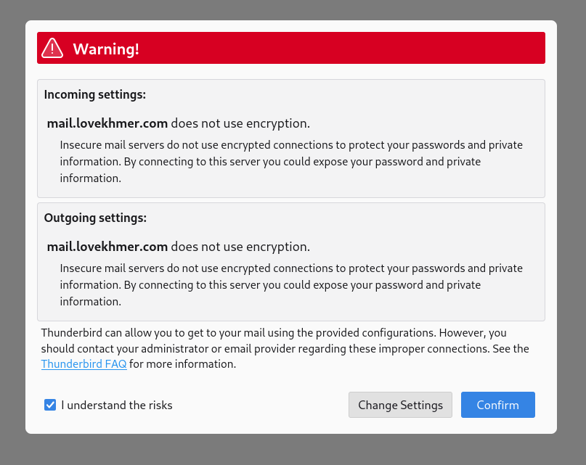

**>> Click Finish.**

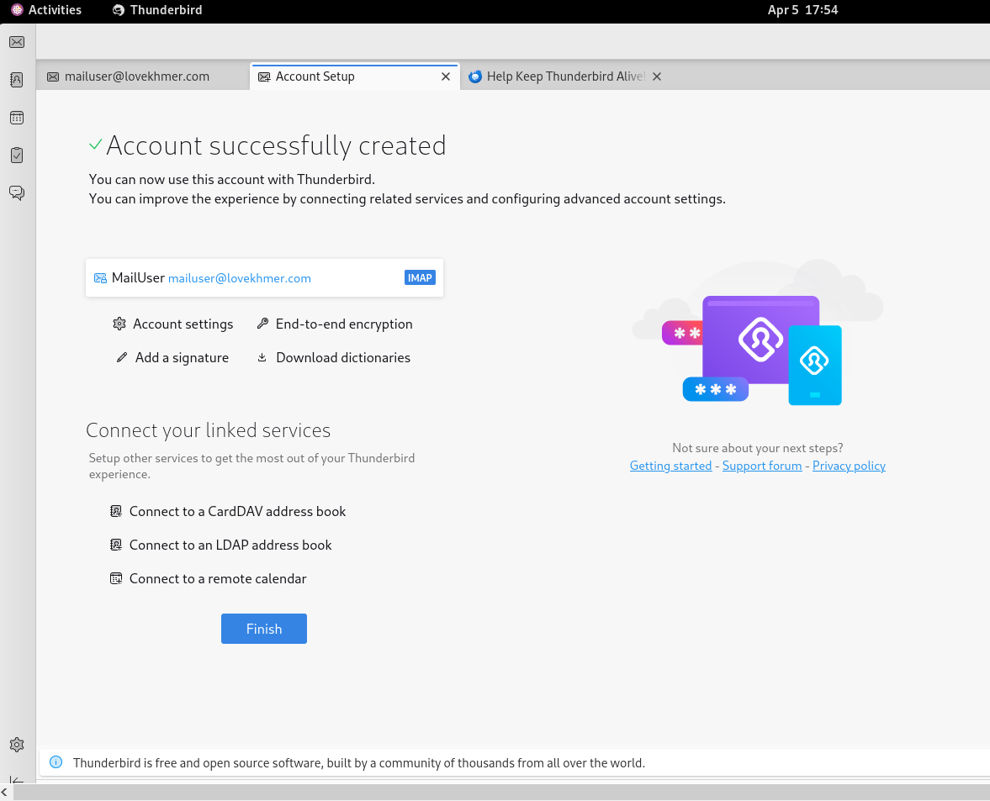

**>> It's possible to send or receive emails like follows.**

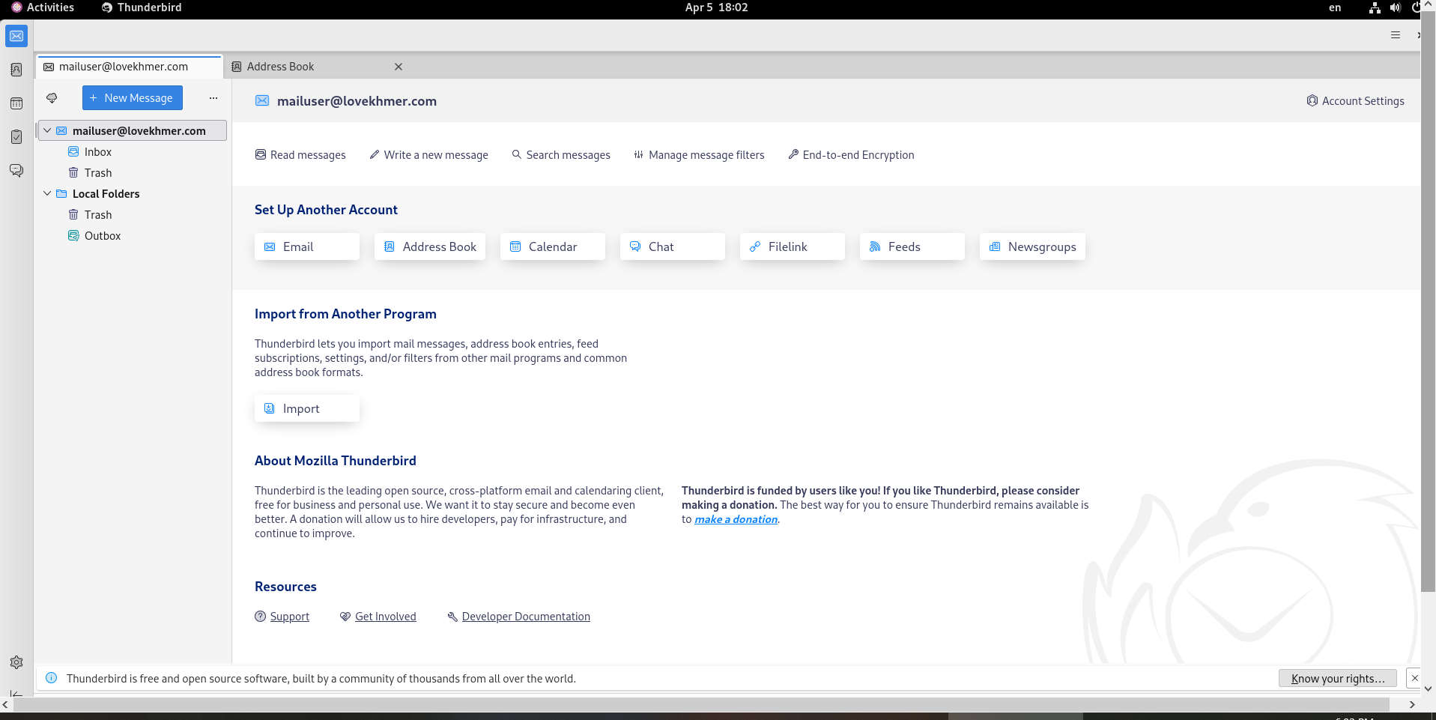

**>> And now you can test to send mail**

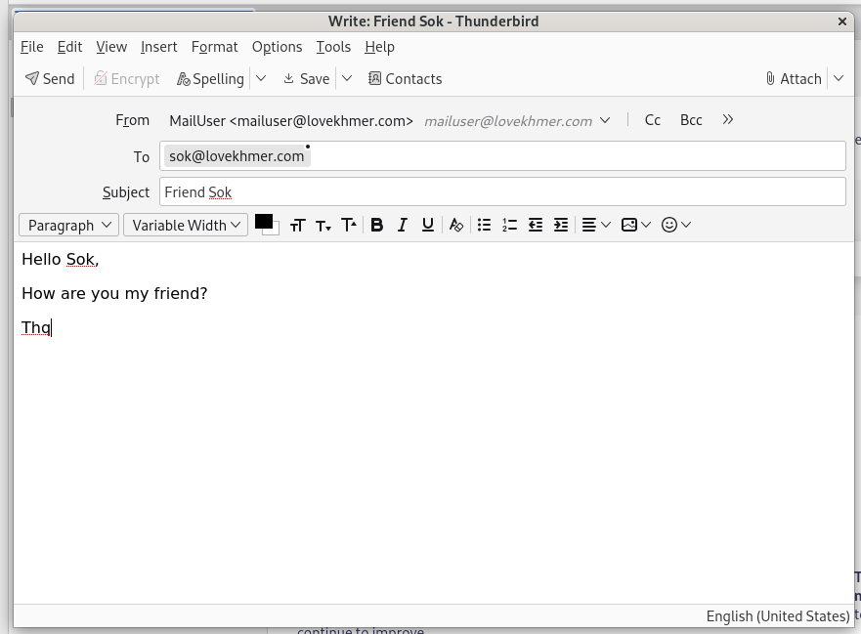

**>> Go to** [**sok@lovekhmer.com**](mailto:sok@lovekhmer.com) **to check Email**

